Banking SQL Project
Phase 1 Documentation
Oracle XE 21c — Schema Setup, User Creation & Grants
Database: Oracle XE 21c | Tool: SQL Developer / SQL*Plus | Level: Intermediate

1. Environment & Prerequisites

Before running any SQL, confirm the following are installed and running on your machine:

- Oracle Database XE 21c — installed and listener running
- Oracle SQL Developer (recommended) or SQL*Plus
- Default SID / Service Name: XE
- Default port: 1521

1.1 Verify Oracle Listener is Running
Open Command Prompt (Windows) and run:

lsnrctl status

Expected Output: STATUS of LISTENER: READY — and you should see Service 'XE' listed.

1.2 Check Oracle Version
-- Run inside SQL*Plus or SQL Developer
SELECT * FROM v$version WHERE banner LIKE 'Oracle%';

Expected Output: Oracle Database 21c Express Edition Release 21.0.0.0.0

2. Connect to Oracle Using System User

We use the built-in SYSTEM user (role: default) to create the banking schema. No SYSDBA or SYS required. SYSTEM user has sufficient privileges to create users, grant roles, and manage schemas.

2.1 SQL Developer Connection — System User
1 | Open SQL Developer and click the + icon to create a new connection

Field | Value
Connection Name | system_xe
Username | system
Password | YourSystemPassword
Role | default
Hostname | localhost
Port | 1521
Service name | XE

2 | Click Test — Status: Success should appear. Then click Connect.

Note: Role must be 'default' — not SYSDBA, not SYSOPER. This is the standard SYSTEM user login for Oracle XE 21c.

2.2 Switch Container to XEPDB1 Using ALTER SESSION
Oracle XE 21c is a Container Database (CDB). When you connect with Service Name XE, you land in the CDB root. You must switch to the Pluggable Database (XEPDB1) before creating users — otherwise Oracle requires C## prefix for usernames.

1 | Run this as the first command after connecting as system user

-- Switch from CDB root (XE) into the Pluggable Database
ALTER SESSION SET CONTAINER = XEPDB1;

-- Verify you are now inside XEPDB1
SHOW CON_NAME;
-- Expected output: CON_NAME = XEPDB1

Expected Output: CON_NAME: XEPDB1 — you are now inside the Pluggable Database. All commands from here apply to XEPDB1.

Note: This ALTER SESSION applies only to your current session. Every time you open a new SQL Developer worksheet, run ALTER SESSION SET CONTAINER = XEPDB1 again before any DDL commands.

3. Create Banking User (Schema)

In Oracle, a schema = a user. When you create a user, Oracle automatically creates an empty schema with the same name. All tables, sequences, and objects for this project will live inside bank schema.

Note: All commands in this section must be run as system user AFTER running ALTER SESSION SET CONTAINER = XEPDB1.

3.1 Create the bank
-- Step 1: Create the user with a strong password
CREATE USER bank IDENTIFIED BY Banking@123;

-- Step 2: Set default tablespace and unlimited storage quota
ALTER USER bank
DEFAULT TABLESPACE users
QUOTA UNLIMITED ON users;

-- Step 3: Set temporary tablespace
ALTER USER bank
TEMPORARY TABLESPACE temp;

Expected Output: User BANK created.

Note: Password Banking@123 satisfies Oracle XE 21c password policy: uppercase + lowercase + digit + special character. Choose your own strong password if preferred.

4. Grant Permissions to bank

Grants give bank the ability to login, create objects, and use the database. Run all these as system user — after running ALTER SESSION SET CONTAINER = XEPDB1.

4.1 Basic Connection & Resource Grants
-- Allow the user to connect (login)
GRANT CREATE SESSION TO bank;

-- Allow creating tables, views, sequences, procedures, triggers
GRANT RESOURCE TO bank;

-- Shortcut: CONNECT role includes CREATE SESSION
GRANT CONNECT TO bank;

4.2 Object-Level Grants (for this project)
-- Create and manage views
GRANT CREATE VIEW TO bank;

-- Create sequences (for auto-increment PKs)
GRANT CREATE SEQUENCE TO bank;

-- Create stored procedures and functions
GRANT CREATE PROCEDURE TO bank;

-- Create triggers
GRANT CREATE TRIGGER TO bank;

-- Execute DBMS packages (needed for some PL/SQL)
GRANT EXECUTE ON DBMS_OUTPUT TO bank;

4.3 All Grants — Reference Table
Grant Command | Purpose
GRANT CREATE SESSION | Login / connect to the database
GRANT CONNECT | Role that includes CREATE SESSION
GRANT RESOURCE | Create tables, sequences, procedures, triggers
GRANT CREATE VIEW | Create views (needed for Phase 4 reporting views)
GRANT CREATE SEQUENCE | Create sequences for auto-increment PKs
GRANT CREATE PROCEDURE | Create stored procedures and functions
GRANT CREATE TRIGGER | Create triggers for audit and automation
GRANT EXECUTE ON DBMS_OUTPUT | Use DBMS_OUTPUT.PUT_LINE in PL/SQL
QUOTA UNLIMITED ON users | Store data in the USERS tablespace (no storage limit)

Note: Do NOT grant DBA role to bank. DBA gives full superuser access which is unnecessary and a security risk for a project schema.

4.4 Verify User and Grants
-- Check user was created
SELECT username, account_status, default_tablespace
FROM dba_users
WHERE username = 'BANK';

-- Check what roles are granted
SELECT granted_role
FROM dba_role_privs
WHERE grantee = 'BANK';

-- Check system privileges granted
SELECT privilege
FROM dba_sys_privs
WHERE grantee = 'BANK'
ORDER BY privilege;

Expected Output: USERNAME: BANK | ACCOUNT_STATUS: OPEN | DEFAULT_TABLESPACE: USERS

5. Login as bank

After all grants are given (while in system user session), open a separate new connection in SQL Developer for bank. All schema objects — sequences, tables, indexes — must be created under this connection.

5.1 New Connection in SQL Developer for bank
Field | Value
Connection Name | banking_project
Username | bank
Password | Banking@123
Role | default (leave blank)
Hostname | localhost
Port | 1521
Service name | XEPDB1

Expected Output: Status: Success — you are now inside the bank schema.

6. Create Sequences (Auto-Increment PKs)

Oracle uses SEQUENCES to generate unique primary key values. In Oracle XE 21c (12c+), you can use DEFAULT seq.NEXTVAL directly in the CREATE TABLE statement — no triggers needed.

Run these as bank:

-- Primary key sequences for all 7 tables
CREATE SEQUENCE seq_branch_id
START WITH 1 INCREMENT BY 1 NOCACHE NOCYCLE;

CREATE SEQUENCE seq_employee_id
START WITH 1 INCREMENT BY 1 NOCACHE NOCYCLE;

CREATE SEQUENCE seq_customer_id
START WITH 1 INCREMENT BY 1 NOCACHE NOCYCLE;

CREATE SEQUENCE seq_account_id
START WITH 1 INCREMENT BY 1 NOCACHE NOCYCLE;

CREATE SEQUENCE seq_transaction_id
START WITH 1 INCREMENT BY 1 NOCACHE NOCYCLE;

CREATE SEQUENCE seq_loan_id
START WITH 1 INCREMENT BY 1 NOCACHE NOCYCLE;

CREATE SEQUENCE seq_payment_id
START WITH 1 INCREMENT BY 1 NOCACHE NOCYCLE;

Verify Sequences
SELECT sequence_name, min_value, max_value, increment_by, cycle_flag
FROM user_sequences
ORDER BY sequence_name;

Expected Output: 7 rows returned — all sequences created successfully.

7. Create Tables (DDL Scripts)

Run all CREATE TABLE statements as bank inside XEPDB1. The order matters — parent tables must be created before child tables that reference them via foreign keys.

Correct order: BRANCHES → EMPLOYEES → CUSTOMERS → ACCOUNTS → TRANSACTIONS → LOANS → LOAN_PAYMENTS

Table 1 — BRANCHES
CREATE TABLE branches (
branch_id NUMBER DEFAULT seq_branch_id.NEXTVAL PRIMARY KEY,
branch_name VARCHAR2(100) NOT NULL,
city VARCHAR2(50) NOT NULL,
state VARCHAR2(50) NOT NULL,
phone VARCHAR2(15),
established_date DATE DEFAULT SYSDATE
);

Table 2 — EMPLOYEES
CREATE TABLE employees (
employee_id NUMBER DEFAULT seq_employee_id.NEXTVAL PRIMARY KEY,
branch_id NUMBER NOT NULL,
first_name VARCHAR2(50) NOT NULL,
last_name VARCHAR2(50) NOT NULL,
job_title VARCHAR2(100),
salary NUMBER(12, 2) NOT NULL,
hire_date DATE DEFAULT SYSDATE,
CONSTRAINT fk_emp_branch
FOREIGN KEY (branch_id) REFERENCES branches(branch_id)
);

Table 3 — CUSTOMERS
CREATE TABLE customers (
customer_id NUMBER DEFAULT seq_customer_id.NEXTVAL PRIMARY KEY,
branch_id NUMBER NOT NULL,
first_name VARCHAR2(50) NOT NULL,
last_name VARCHAR2(50) NOT NULL,
email VARCHAR2(100) UNIQUE NOT NULL,
phone VARCHAR2(15),
city VARCHAR2(50),
date_of_birth DATE,
joined_date DATE DEFAULT SYSDATE,
CONSTRAINT fk_cust_branch
FOREIGN KEY (branch_id) REFERENCES branches(branch_id)
);

Table 4 — ACCOUNTS
CREATE TABLE accounts (
account_id NUMBER DEFAULT seq_account_id.NEXTVAL PRIMARY KEY,
customer_id NUMBER NOT NULL,
branch_id NUMBER NOT NULL,
account_type VARCHAR2(20) NOT NULL
CONSTRAINT chk_acc_type
CHECK (account_type IN ('SAVINGS','CURRENT','FIXED_DEPOSIT','SALARY')),
balance NUMBER(15, 2) DEFAULT 0 NOT NULL,
status VARCHAR2(10) DEFAULT 'ACTIVE'
CONSTRAINT chk_acc_status
CHECK (status IN ('ACTIVE','INACTIVE','CLOSED','FROZEN')),
opened_date DATE DEFAULT SYSDATE,
CONSTRAINT fk_acc_customer
FOREIGN KEY (customer_id) REFERENCES customers(customer_id),
CONSTRAINT fk_acc_branch
FOREIGN KEY (branch_id) REFERENCES branches(branch_id)
);

Table 5 — TRANSACTIONS
CREATE TABLE transactions (
transaction_id NUMBER DEFAULT seq_transaction_id.NEXTVAL PRIMARY KEY,
account_id NUMBER NOT NULL,
transaction_type VARCHAR2(20) NOT NULL
CONSTRAINT chk_txn_type
CHECK (transaction_type IN
('DEPOSIT','WITHDRAWAL','TRANSFER','INTEREST','FEE')),
amount NUMBER(15, 2) NOT NULL,
transaction_date DATE DEFAULT SYSDATE,
description VARCHAR2(200),
status VARCHAR2(10) DEFAULT 'SUCCESS'
CONSTRAINT chk_txn_status
CHECK (status IN ('SUCCESS','FAILED','PENDING')),
CONSTRAINT fk_txn_account
FOREIGN KEY (account_id) REFERENCES accounts(account_id)
);

Table 6 — LOANS
CREATE TABLE loans (
loan_id NUMBER DEFAULT seq_loan_id.NEXTVAL PRIMARY KEY,
customer_id NUMBER NOT NULL,
branch_id NUMBER NOT NULL,
loan_type VARCHAR2(30) NOT NULL
CONSTRAINT chk_loan_type
CHECK (loan_type IN
('HOME','PERSONAL','AUTO','EDUCATION','BUSINESS')),
principal_amount NUMBER(15, 2) NOT NULL,
interest_rate NUMBER(5, 2) NOT NULL,
tenure_months NUMBER(3) NOT NULL,
start_date DATE DEFAULT SYSDATE,
end_date DATE,
status VARCHAR2(15) DEFAULT 'ACTIVE'
CONSTRAINT chk_loan_status
CHECK (status IN
('ACTIVE','CLOSED','DEFAULTED','APPROVED','REJECTED')),
CONSTRAINT fk_loan_customer
FOREIGN KEY (customer_id) REFERENCES customers(customer_id),
CONSTRAINT fk_loan_branch
FOREIGN KEY (branch_id) REFERENCES branches(branch_id)
);

Table 7 — LOAN_PAYMENTS
CREATE TABLE loan_payments (
payment_id NUMBER DEFAULT seq_payment_id.NEXTVAL PRIMARY KEY,
loan_id NUMBER NOT NULL,
amount_paid NUMBER(15, 2) NOT NULL,
payment_date DATE DEFAULT SYSDATE,
payment_mode VARCHAR2(20) DEFAULT 'BANK_TRANSFER'
CONSTRAINT chk_pay_mode
CHECK (payment_mode IN
('BANK_TRANSFER','CASH','CHEQUE','ONLINE')),
CONSTRAINT fk_pay_loan
FOREIGN KEY (loan_id) REFERENCES loans(loan_id)
);

8. Create Indexes

Indexes speed up query performance on columns used in WHERE clauses, JOINs, and ORDER BY. These indexes are critical for Phase 3 analytical queries and Power BI report load times.

-- Customer lookups by branch
CREATE INDEX idx_customers_branch ON customers(branch_id);

-- Account lookups by customer
CREATE INDEX idx_accounts_customer ON accounts(customer_id);

-- Transaction filtering by date (most used in Power BI)
CREATE INDEX idx_transactions_date ON transactions(transaction_date);

-- Transaction filtering by account
CREATE INDEX idx_transactions_accid ON transactions(account_id);

-- Loan lookups by customer
CREATE INDEX idx_loans_customer ON loans(customer_id);

-- Loan filtering by status (ACTIVE / DEFAULTED / CLOSED)
CREATE INDEX idx_loans_status ON loans(status);

-- Payment lookups by loan
CREATE INDEX idx_loan_payments_loan ON loan_payments(loan_id);

9. Verify Everything

Run these verification queries as bank to confirm the schema is complete and ready for Phase 2.

9.1 Check All Tables Exist
SELECT table_name
FROM user_tables
ORDER BY table_name;

Expected Output: 7 rows: ACCOUNTS, BRANCHES, CUSTOMERS, EMPLOYEES, LOAN_PAYMENTS, LOANS, TRANSACTIONS

9.2 Check All Sequences Exist
SELECT sequence_name
FROM user_sequences
ORDER BY sequence_name;

Expected Output: 7 rows: SEQ_ACCOUNT_ID, SEQ_BRANCH_ID, SEQ_CUSTOMER_ID, SEQ_EMPLOYEE_ID, SEQ_LOAN_ID, SEQ_PAYMENT_ID, SEQ_TRANSACTION_ID

9.3 Check All Constraints
SELECT constraint_name, constraint_type, table_name, status
FROM user_constraints
WHERE table_name IN ('BRANCHES','EMPLOYEES','CUSTOMERS',
'ACCOUNTS','TRANSACTIONS','LOANS','LOAN_PAYMENTS')
ORDER BY table_name, constraint_type;

9.4 Quick Row Count After Data Load (Phase 2)
SELECT 'BRANCHES' AS tbl, COUNT(*) AS rows FROM branches UNION ALL
SELECT 'EMPLOYEES' AS tbl, COUNT(*) AS rows FROM employees UNION ALL
SELECT 'CUSTOMERS' AS tbl, COUNT(*) AS rows FROM customers UNION ALL
SELECT 'ACCOUNTS' AS tbl, COUNT(*) AS rows FROM accounts UNION ALL
SELECT 'TRANSACTIONS' AS tbl, COUNT(*) AS rows FROM transactions UNION ALL
SELECT 'LOANS' AS tbl, COUNT(*) AS rows FROM loans UNION ALL
SELECT 'LOAN_PAYMENTS' AS tbl, COUNT(*) AS rows FROM loan_payments;

9.5 Test Sequence is Working
-- Insert one test branch to confirm sequence fires
INSERT INTO branches (branch_name, city, state, phone)
VALUES ('Main Branch', 'Chennai', 'Tamil Nadu', '044-12345678');

SELECT branch_id, branch_name, city FROM branches;

-- Rollback the test row (we will insert real data in Phase 2)
ROLLBACK;

Expected Output: BRANCH_ID: 1 | BRANCH_NAME: Main Branch | CITY: Chennai — sequence is working!

10. Common Errors & Fixes

Error | Cause | Fix
ORA-65096 | Creating user in CDB root | ALTER SESSION SET CONTAINER = XEPDB1; before CREATE USER
ORA-00955 | Object already exists | DROP SEQUENCE / DROP TABLE before recreating
ORA-02291 | FK parent key not found | Check creation order — BRANCHES must exist before EMPLOYEES
ORA-01950 | No privileges on tablespace | Run: ALTER USER bank QUOTA UNLIMITED ON users
ORA-28003 | Password verification failed | Use strong password: Banking@123 (upper+lower+digit+special)
ORA-01017 | Invalid username/password | Check spelling; Oracle usernames are case-insensitive but passwords are case-sensitive

Phase 1 Complete — Ready for Phase 2: Sample Data Loading
Oracle XE 21c | bank schema | 7 tables | 7 sequences | 7 indexes

11. Entity Relationship Diagram (ERD)

The ERD below shows all 7 tables, their columns with data types, primary keys (PK), foreign keys (FK), and the relationships between them.

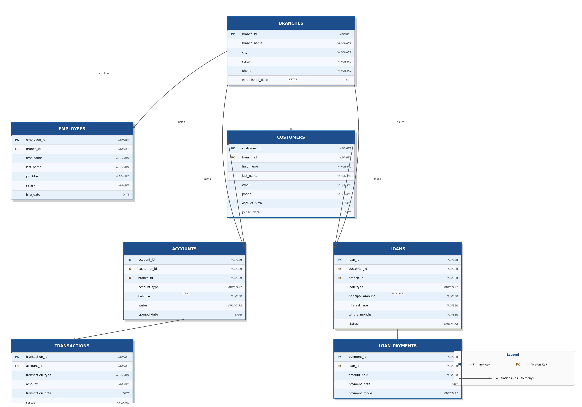

Fig 1: Banking Database — Entity Relationship Diagram (Oracle XE 21c)

